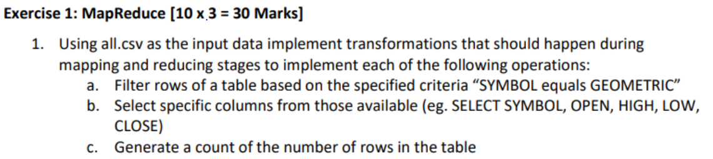

MAPPER 1:

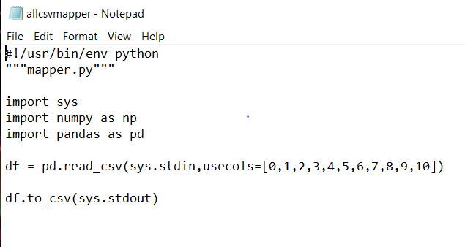

NOTE: MAPPER IS SAME FOR ALL REDUCERS

REDUCER 1: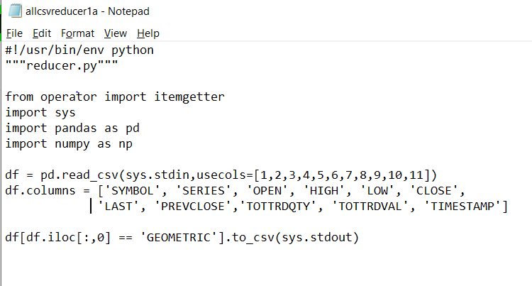

OUTPUT 1:

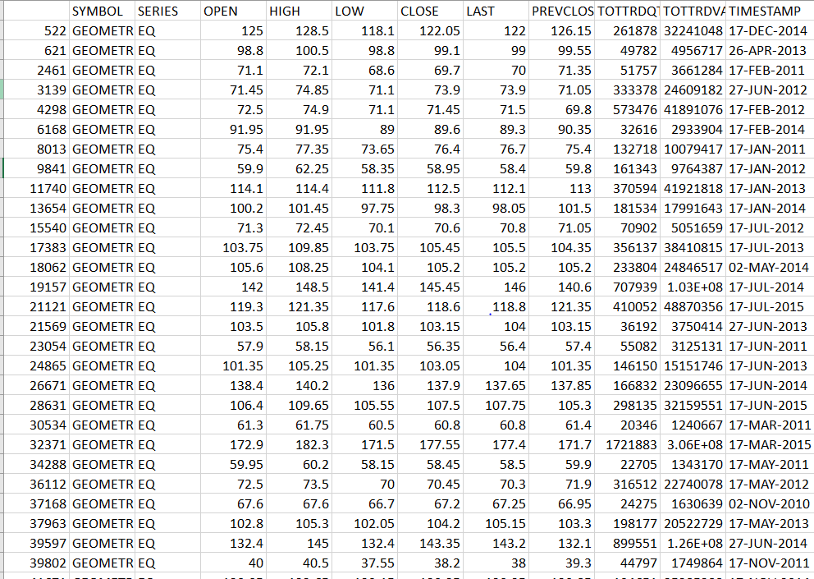

REDUCER 2:

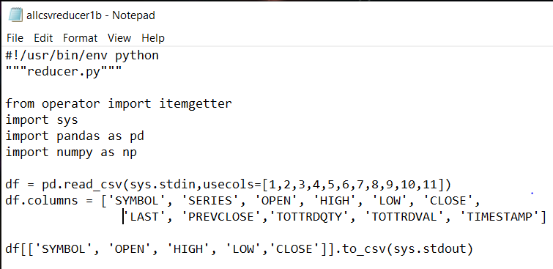

OUTPUT 2:

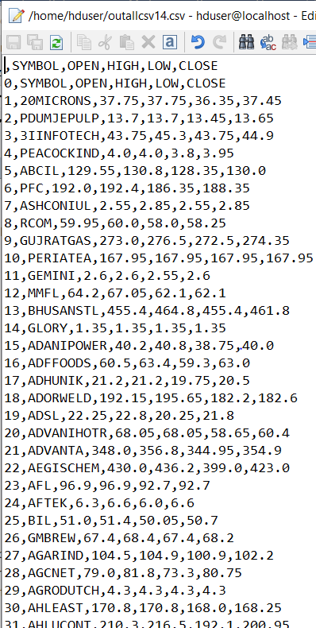

REDUCER 3:

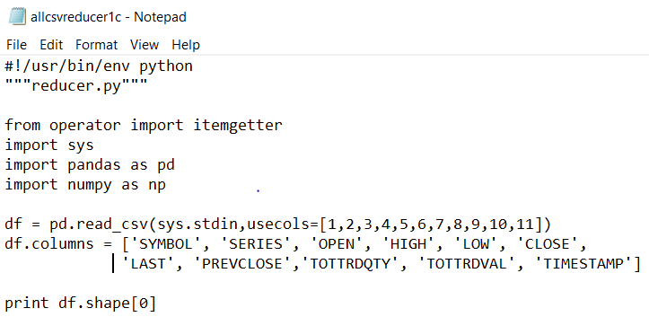

OUTPUT 3:



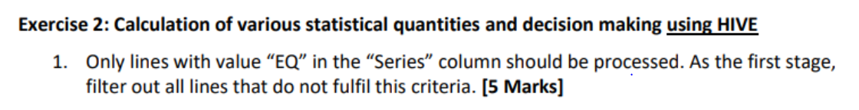

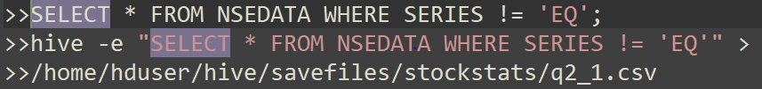

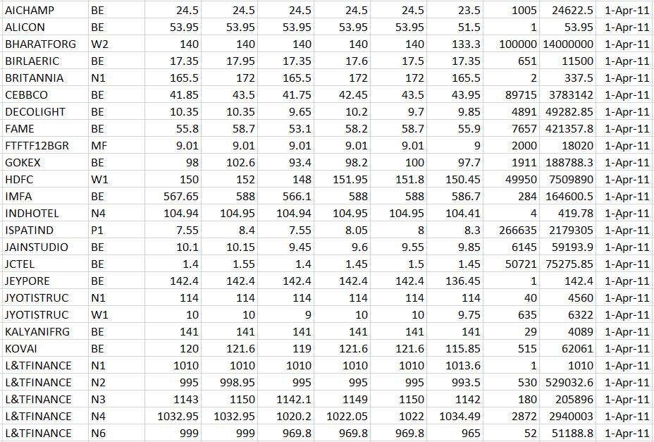

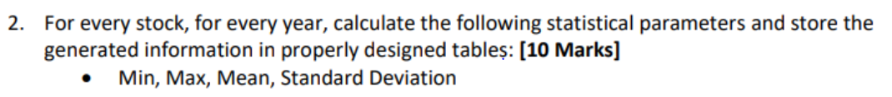

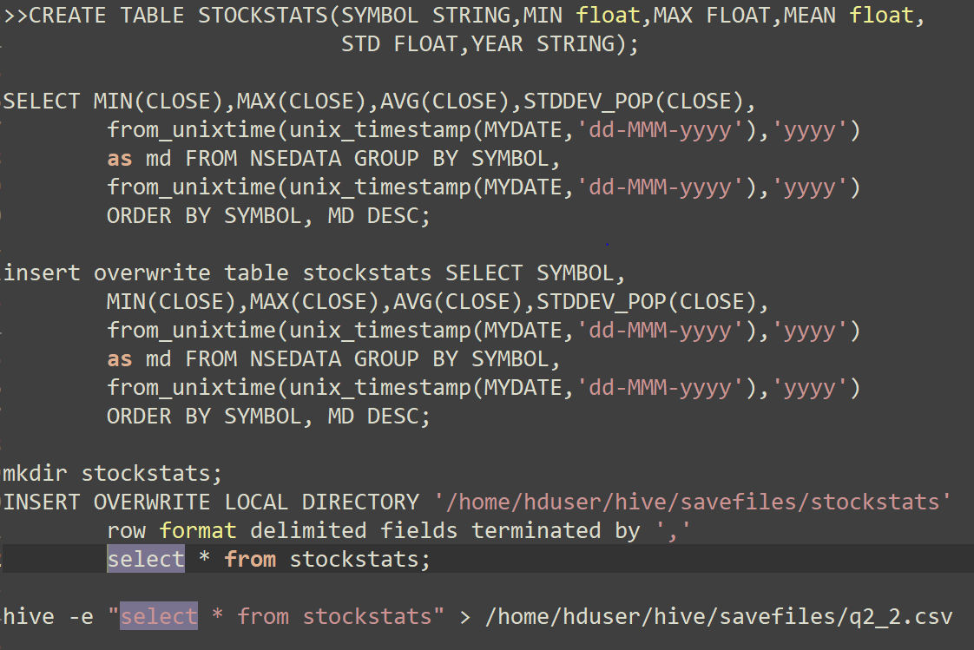

SYMBOL MIN MAX AVG. STDDEV YEAR

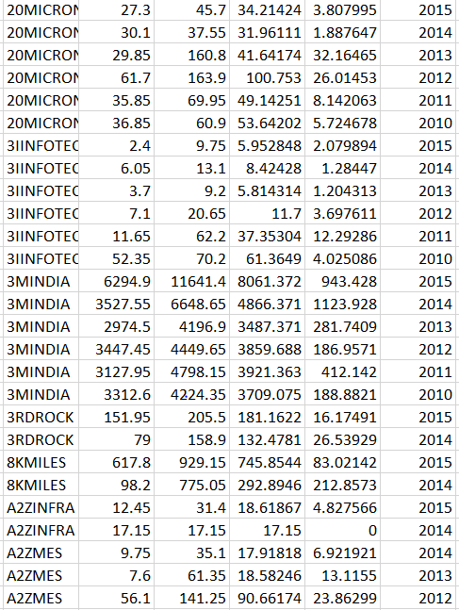

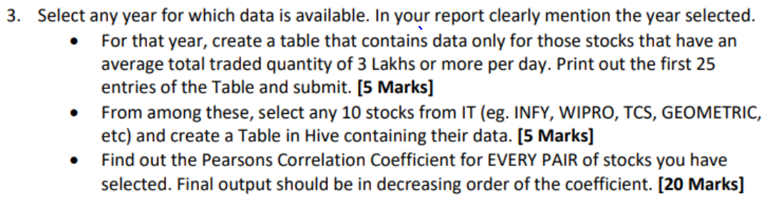

SELECTING YEAR 2013

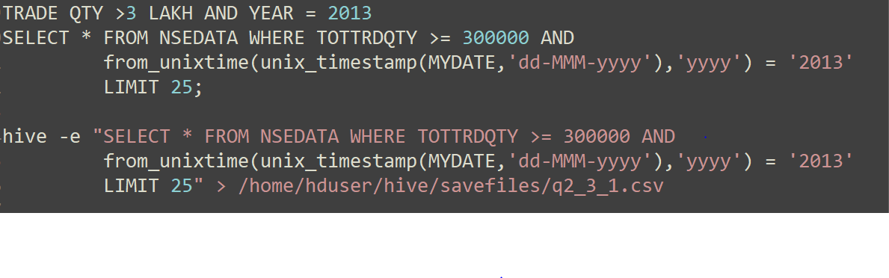

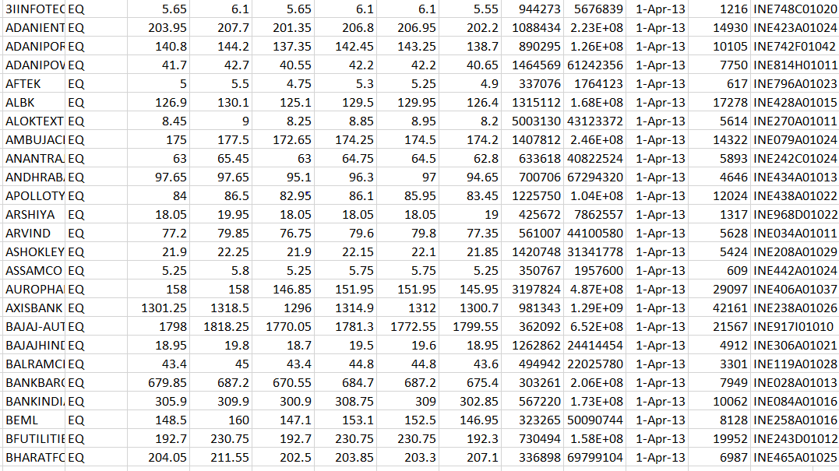



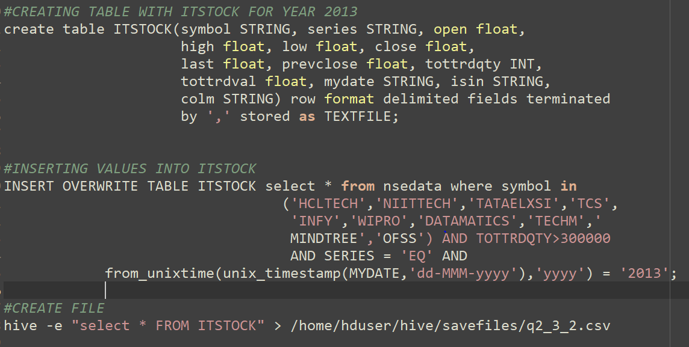

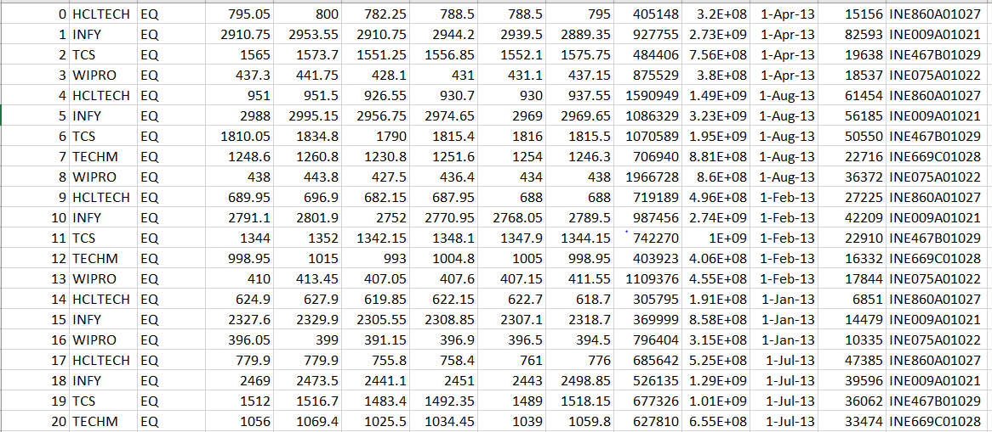



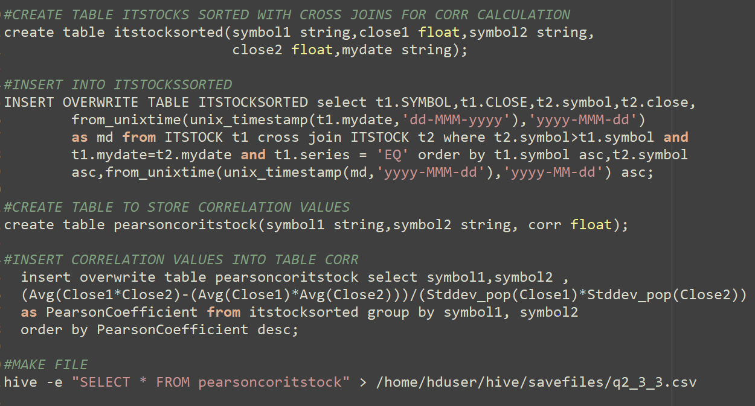

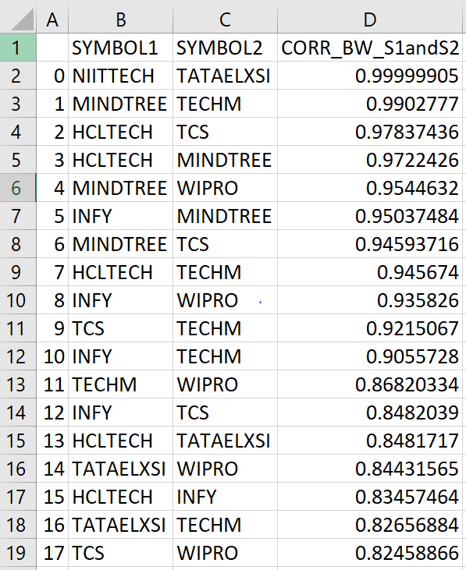

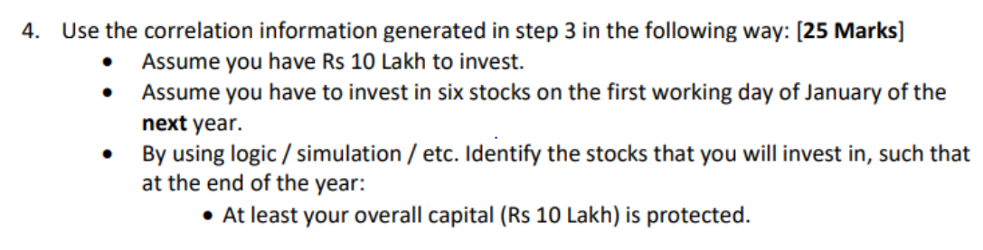

STEPS FOLLOWED:

* SELECTED YEAR 2013 WITH 10 IT STOCKS
* CALCULATED CORRELATION BETWEEN EACH STOCKS WITH CROSS JOIN
* CALCULATED GROWTH PERCENTAGE OF EACH STOCK FROM 2011 TO 2013
* SELECTED STOCKS WITH HIGH GROWTH PERCENTAGE AND RANKED THEM FOR DECISION ON CAPITAL INVESTMENT IN EACH STOCK
* SELECTED STOCKS ARE >> ['MINDTREE', 'TCS', 'INFY', 'OFSS', 'TECHM', 'HCLTECH']
* SELECTED OFSS AS IT HAS NEGATIVE CORRELATION WITH TCS AND INFY AND ASSIGNED MAX CAPITAL ON IT AS CORRELATION IS APROX. 0.5
* AS PER RANKING TOOK DECISION ON HOW MUCH CAPITAL TO BE INVESTED AND

ON FOLLOWING PAGE IS EXCEL SHEET OF STOCKS SELECTED AND CODE TO GET ALL THE DATAFRAMES

